News Release

Thunder Mountain Gold, Inc. Purchases Land at South Mountain, and Announces Results of Annual Meeting

Boise, Idaho – December 13, 2023: Thunder Mountain Gold, Inc. (OTCQB: THMG; TSX-V: THM), (the “Company” or “THMG”) announced today that it has purchased an additional 56 acres of strategic land at the Company`s South Mountain Project.
The land is a combination of both patented and private land, with full mineral rights, and was previously leased by the Company. The parcel is contiguous with the South Mountain patented claims and is important to the future development of the Texas Zone. This land acquisition covers a gap in the main mine area and eliminates any outside ownership within the main mine area.
Location of South Mountain Project
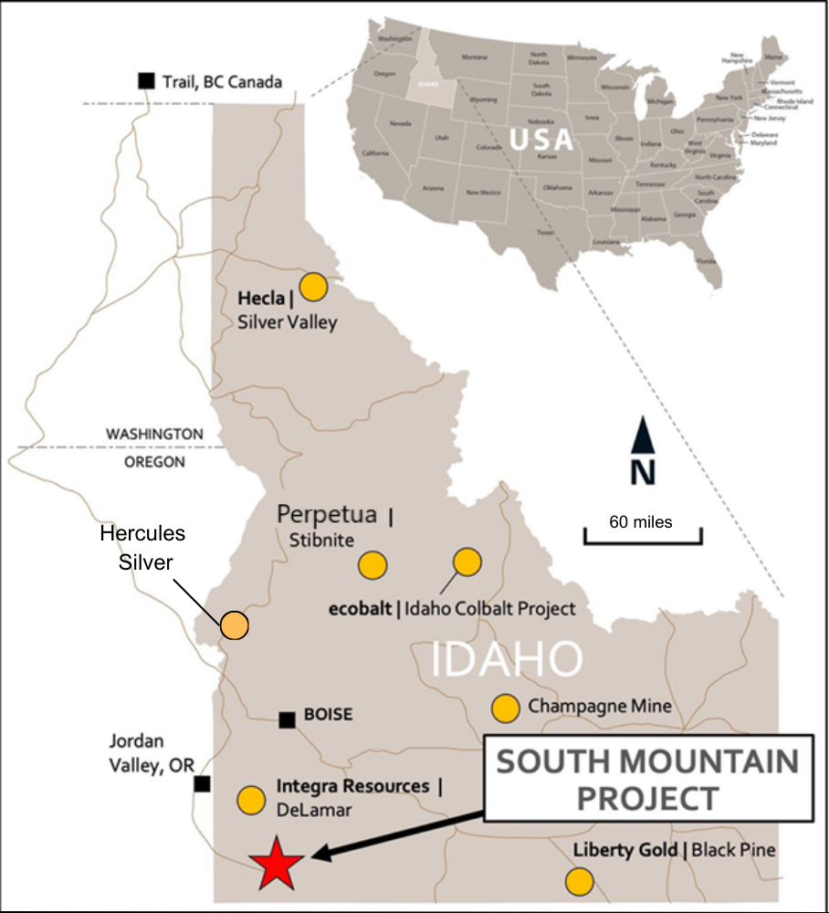
Eric T. Jones, President and CEO of Thunder Mountain Gold Inc. commented, “We are pleased to have the ability to acquire this strategic land. This purchase adds a great deal of value to the project and fills in a critical piece to our private and patented land position at South Mountain”.
Terms of the purchase were $50,000 plus closing costs.
RESULTS of the COMPANY`S ANNUAL MEETING
The Company recently held its annual shareholder meeting. The Company’s shareholders approved three proposals at their Annual Meeting.
Of the 60,885,579 eligible votes, representing shares of the Company’s Common Stock outstanding, as of the record date of October 16, 2023, 33,450,567 shares by proxy were represented at the Annual Meeting. The Company's shareholders voted on three proposals listed below, that were described in detail in the Company's definitive proxy statement for the Annual Meeting.
The shareholders elected each of the seven director nominees set forth below, to serve a one-year term, expiring at the next Annual Meeting of Shareholders. The directors elected were Paul Beckman, E. James Collord, Douglas J. Glaspey, Eric T. Jones, Larry D. Kornze, Ralph Noyes, and James A. Sabala.
The shareholders also ratified and reapproved the Stock Option Plan, and ratified and reapproved the appointment of DeCoria, Maichel & Teague P.S. as independent auditors.
No other items were presented for shareholder approval at the Annual Meeting. The Company`s Transfer Agent - Computershare Investor Services, of Denver, Colorado - served as Inspector of Voting.
The Company reported and summarized these results by Form 8-K on the SEC Electronic Data Gathering, Analysis, and Retrieval system, (EDGAR), found at www.sec.gov/edgar.
ADDITIONAL CORPORATE NEWS
The Company also recently reported an updated Mineral Resource Estimate (“MRE”) incorporating results from surface diamond drilling program conducting in 2021 at the South Mountain Project (“South Mountain” or “South Mountain Project” or the “Property”) in southwestern Idaho, U.S.A (see figure below). The updated MRE includes an increased resource for the Project while maintaining the high-grade mineralization.
The updated Independent MRE, which has an effective date of October 16, 2023, was prepared in accordance with National Instrument 43-101 Standards of Disclosure for Mineral Projects (“NI-43-101”) by Hard Rock Consulting, LLC, based in the U.S.A. A technical report for this MRE will be filed with SEDAR, and on the Company’s website, within 45 days from the date of this news release. A summary of the Independent Resource Estimate in accordance with Regulation S-K (Subpart 1300) will also be included with the Company`s 2023 Form 10-K.
Mr. Richard A. Schwering, P.G., SME-RM, a Resource Geologist with Hard Rock Consulting, LLC, is responsible for the South Mountain Project Mineral Resource Estimate with an effective date of October 16, 2023. Mr. Schwering is a Qualified Person as defined by NI43-101 and is independent of Thunder Mountain Gold Inc., and South Mountain Mines, Inc.

Regarding The South Mountain Project

The South Mountain Mine is a polymetallic development project focused on high-grade zinc, silver, gold, and copper, and is located approximately 70 miles southwest of Boise, Idaho (See Figure 2). The Project was intermittently mined from the late 1800s to the late 1960s (most notably by Anaconda Mining) and its existing underground workings remain intact and well maintained. Thunder Mountain Gold Inc. purchased and advanced the project from 2007 through 2022, with expenditures into the project of approximately US$20 million. Historic production at the Project has largely come from high-grade massive sulfide bodies that remain open at depth and along strike. According to historical smelter records, approximately 53,642 tons of mineralized material has been mined to date. These records also indicate average grades; 14.5% Zn, 10.6 o.p.t. Ag (363.42 g/t Ag), 0.058 o.p.t. Au (1.98 g/t Au), 1.4% Cu, and 2.4% Pb were realized (See NI 43-101 Technical Report: Updated Mineral Resource Estimate for the South Mountain Project, dated June 15, 2021, Section 6.4 – Table 6-3 for more details. More information available on the Thunder Mountain Gold Inc. website and at www.sedar.com).

Regarding Thunder Mountain Gold, Inc.
Thunder Mountain Gold Inc., a junior exploration company founded in 1935, owns interests in base and precious metals projects in the western U.S. The Company’s principal asset is The South Mountain Mine, a historic former producer of zinc, silver, gold, lead, and copper, located on private land in Owyhee County Idaho. Thunder Mountain Gold also owns 100% of the Trout Creek Project – a gold exploration project located along the western flank of the Shoshone Mountain Range in the Reese River Valley, adjacent to and surrounded by Nevada Gold Mines, a joint operating agreement between Barrick and Newmont Gold, Inc. private mineral lands. For more information on Thunder Mountain Gold, please visit the Company’s website at www.Thundermountaingold.com.

Forward-Looking Statements
This press release contains forward-looking statements that are based on the beliefs of management and reflect the Company's current expectations. Generally, forward-looking statements can be identified by the use of forward-looking terminology such as “plans”, “expects”, “is expected”, “budget”, “scheduled”, “estimates”, “forecasts”, “intends”, “anticipates”, “believes” or variations of such words and phrases or statements that certain actions, events or results “may”, “could”, “would”, “might” or “will be taken”, “occur” or “be achieved” or the negative connotation thereof. The forward-looking statements are based on certain assumptions which could change materially in the future. By their nature, forward-looking information involves known and unknown risks, uncertainties and other factors that may cause actual results, performance or achievements to be materially different from any future results, performance or achievements expressed or implied by the forward-looking information. Investors should refer to THMG’s Form 10-K, Form 10-Q reports, for a more detailed discussion of risks that may impact future results. There can be no assurance that forward-looking information will prove to be accurate, as actual results and future events could differ materially from those anticipated in such statements. Accordingly, investors should not place undue reliance on forward-looking information. Forward-looking information is provided as of the date of this press release, and the Company assumes no obligation to update or revise them to reflect new events or circumstances, except as required in accordance with applicable laws.

Cautionary Note to Investors
Neither the TSX Venture Exchange nor its Regulation Services Provider (as that term is defined in policies of the TSX Venture Exchange) accepts responsibility for the adequacy or accuracy of this release.

For further information, please contact:

Thunder Mountain Gold, Inc.
Eric T. Jones
President and Chief Executive Officer
Eric@thundermountaingold.com
Office: (208) 658-1037

