News Release

Thunder Mountain Gold, Inc. Updated 43-101 Mineral Resource Estimate at South Mountain Shows Significant Increase.

- 7.7% increase to the Measured & Indicated tonnage, including a significant increase in zinc, silver, gold, and copper.

- 15.1% increase in the Inferred tonnage, including a 14% increase in zinc and silver.

- The DMEA Zone extended an additional 250 feet.

Boise, Idaho – December 21, 2023: Thunder Mountain Gold, Inc. (OTCQB: THMG; TSX-V: THM), (the “Company” or “THMG”) is pleased to report a newly filed NI 43-101 Mineral Resource Estimate (“43-101 43-101 MRE”) incorporating results from surface diamond drilling program conducting in 2021 at the South Mountain Project (“South Mountain” or “South Mountain Project” or the “Property”) in southwestern Idaho, U.S.A. The updated 43-101 MRE includes an increased resource for the Project while maintaining the high-grade mineralization.
The updated Independent 43-101 MRE, which has an effective date of October 16, 2023, was prepared in accordance with National Instrument 43-101 Standards of Disclosure for Mineral Projects (“NI-43-101”) by Hard Rock Consulting, LLC, based in the U.S.A. More details are included in Table 1 below.
HIGHLIGHTS OF UPDATED MINERAL RESOURCE
- Measured & Indicated (“M&I”): 223,000 tons grading 9.02% Zinc (“Zn”), 4.27 ounces per ton (“opt”) Silver (“Ag”), 0.059 opt Gold (“Au”), 0.64% Copper (“Cu”), and 0.94% Lead (“Pb”).
- This represents a 7.7% increase to the M&I tonnage from the previous 2021 43-101 MRE, with a 18.82% Zn equivalent grade (“ZnEq”), or a 20.55opt Ag equivalent grade (“AgEq”)
- Inferred: 959,000 tons grading 7.56% Zn (14% increase in Zn lbs), 5.67 opt Ag (14.10% increase in Ag ounces), 0.037 opt Au (3.3% increase in Au ounces), 0.80% Cu (14.5% increase in Cu lbs), and 1.06% Pb (25.4% increase in Pb lbs).
- This represents a 15.1% increase in the Inferred tonnage from the previous 2021 43-101 MRE with an 17.2% ZnEq or a 19.30 opt AgEq.
- The DMEA Zone in the model was extended an additional 250 feet down dip and remains open.
“We are extremely pleased by the results of the revised 43-101 MRE. These deep surface core holes placed to determine the continued downdip potential of the mineralization displayed positive results on our resource. Our independent engineering firm – Hard Rock Consulting, LLC – did a great job with the data. This new data supports previously reported model and results confirming the continuation of all mineralized zones extending down-plunge, and that they continue to remain open at depth,” commented Eric T. Jones, President and CEO of Thunder Mountain Gold Inc. “It is still our opinion that South Mountain has the potential to be one of the lowest cost producers of zinc, silver, and gold in north America”.
MINERAL RESOURCE ESTIMATE
This latest round of drilling completed during the late fall of 2021 proves the continuation of the down plunge extension of the DMEA zone at depth. This zone remains open in both directions. All the of the drill results have now been in incorporated into the updated 43-101 MRE for the South Mountain deposit. The increase in Measured and Indicated tons are the result of updated metal prices and mining costs. Surface drilling completed in 2021 accounts for approximately 8% of the increase in Inferred tons, while the remaining 7% increase is due to updated metal prices and mining costs.
Table 1 below provides the Mineral Resource Statement for the Project in U.S. units with details of the modelling methodology and cut-off grades applied to the mineral resource. Figure 1 illustrates the principal areas where the South Mountain deposit has been expanded from the historical 43-101 MRE that was completed in 2021. The historical Technical Report for the Mineral Resource Estimate for the South Mountain Project Owyhee County, Idaho USA Report Date: June 15, 2021 - is filed on SEDAR.
Table 1. South Mountain Mineral Resource Statement (U.S. Units)
Metallurgical Domain | Massive Sulfide Type
Classification | Measured | Indicated | Measured + Indicated | Inferred
Short Tons | 54,000 | 122,000 | 176,000 | 868,000
NSR ($/sh. Ton) | 343.35 | 370.05 | 361.92 | 307.62
Zinc (%) | 11.51 | 11.15 | 11.26 | 8.25
Zinc (lb.) | 12,300,000 | 27,300,000 | 39,600,000 | 143,200,000
Silver (t. oz/ sh. Ton) | 3.62 | 4.74 | 4.39 | 5.96
Silver (t. oz) | 194,000 | 580,000 | 774,000 | 5,177,000
Gold (t. oz/ sh. Ton) | 0.070 | 0.074 | 0.073 | 0.040
Gold (t. oz) | 3,800 | 9,100 | 12,900 | 34,700
Copper (%) | 0.45 | 0.55 | 0.52 | 0.74
Copper (lb.) | 500,000 | 1,300,000 | 1,800,000 | 12,800,000
Lead (%) | 0.79 | 1.32 | 1.16 | 1.16
Lead (lb.) | 850,000 | 3,240,000 | 4,080,000 | 20,200,000
ZnEq (%) | 19.54 | 20.93 | 20.51 | 17.69
ZnEq (lb.) | 20,900,000 | 51,200,000 | 72,200,000 | 307,200,000
Metallurgical Domain | Skarn Type
Classification | Measured | Indicated | Measured + Indicated | Inferred
Short Tons | 15,000 | 32,000 | 47,000 | 91,000
NSR ($/sh. Ton) | 196.71 | 149.31 | 164.73 | 166.76
Zinc (%) | 0.99 | 0.44 | 0.62 | 1.02
Zinc (lb.) | 300,000 | 300,000 | 600,000 | 1,900,000
Silver (t. oz/ sh. Ton) | 4.61 | 3.44 | 3.82 | 2.86
Silver (oz/ sh. Ton) | 70,000 | 109,000 | 179,000 | 261,000
Gold (t. oz/ sh. Ton) | 0.017 | 0.005 | 0.009 | 0.005
Gold (oz/ sh. Ton) | 300 | 100 | 400 | 400
Copper (%) | 1.12 | 1.12 | 1.12 | 1.41
Copper (lb.) | 300,000 | 700,000 | 1,000,000 | 2,600,000
Lead (%) | 0.27 | 0.07 | 0.13 | 0.04
Lead (lb.) | 80,000 | 40,000 | 120,000 | 70,000
ZnEq (%) | 14.83 | 11.38 | 12.50 | 12.65
ZnEq (lb.) | 4,500,000 | 7,200,000 | 11,700,000 | 23,100,000
Metallurgical Domain | Total
Classification | Measured | Indicated | Measured + Indicated | Inferred
Short Tons | 69,000 | 154,000 | 223,000 | 959,000
NSR ($/sh. Ton) | 310.88 | 324.73 | 320.46 | 294.21
Zinc (%) | 9.18 | 8.95 | 9.02 | 7.56
Zinc (lb.) | 12,600,000 | 27,600,000 | 40,200,000 | 145,000,000
Silver (t. oz/ sh. Ton) | 3.84 | 4.47 | 4.27 | 5.67
Silver (oz/ sh. Ton) | 264,000 | 688,000 | 953,000 | 5,438,000
Gold (t. oz/ sh. Ton) | 0.058 | 0.060 | 0.059 | 0.037
Gold (oz/ sh. Ton) | 4,000 | 9,300 | 13,300 | 35,200
Copper (%) | 0.60 | 0.66 | 0.64 | 0.80
Copper (lb.) | 800,000 | 2,000,000 | 2,900,000 | 15,400,000
Lead (%) | 0.67 | 1.06 | 0.94 | 1.06
Lead (lb.) | 930,000 | 3,280,000 | 4,210,000 | 20,270,000
ZnEq (%) | 18.50 | 18.97 | 18.82 | 17.21
ZnEq (lb.) | 25,500,000 | 58,400,000 | 83,900,000 | 330,300,000

- The effective date of the mineral resource estimate is October 16, 2023. The QP for the estimate Mr. Richard A. Schwering, SME-RM, P.G., of Hard Rock Consulting, LLC. is independent of South Mountain Mining, LLC.
- Mineral resources are not mineral reserves and do not have demonstrated economic viability such as diluting materials and allowances for losses that may occur when material is mined or extracted; or modifying factors including but not restricted to mining, processing, metallurgical, infrastructure, economic, marketing, legal, environmental, social and governmental factors.
- Inferred mineral resources are part of a mineral resource for which the grade or quality are estimated on the basis of limited geological evidence and sampling. Inferred mineral resources do not have demonstrated economic viability and may not be converted to mineral reserves. It is reasonably expected, though not guaranteed, that the majority of Inferred mineral resources could be upgraded to Indicated mineral resources with continued exploration.
- The mineral resource is reported at an underground mining cut-off of $97.50 U.S. Net Smelter Return (“NSR”) within coherent wireframe models. The NSR calculation and cut-off is based on the following assumptions: an Au price of $1,800/oz, a Ag price of $23.50/oz, a Pb price of $1.00/lb., a Zn price of $1.35/lb. and a Cu price of $4.00/lb.; Massive Sulfide type metallurgical recoveries and payables of 52.25% for Au, 71.25% for Ag, 71.40% for Zn, 66.50% for Pb, and 49.00% for Cu and a total smelter cost of $33.29; Skarn type metallurgical recoveries and payables of 71.25% for Au, 80.75% for Ag, 51.00% for Zn, 47.50% for Pb, and 87.70% for Cu and a smelter cost of $7.24; assumed mining cost of $65/ton, process costs of $25/ton, general and administrative costs of $7.50/ton. Based on the stated prices and recoveries the NSR formula is calculated as follows; NSR = (Ag grade * Ag price * Ag Recovery and Payable) + (Au grade * Au price * Au Recovery and Payable) + (Pb grade * 20 * Pb Price * Pb Recovery and Payable) + (Cu grade * 20 * Cu Price * Cu Recovery and Payable) + (Zn grade * 20 * Zn Price * Zn Recovery and Payable) for each metallurgical domain. The zinc equivalent grades were calculated as Zn Grade + (((Pb Price * Pb Recovery and Payable) / (Zn Price*Zn Recovery and Payable)) * Pb Grade) + (((Cu Price * Cu Recovery and Payable) / (Zn Price * Zn Recovery and Payable)) * Cu Grade) + (((Ag Price * Ag Recovery and Payable) / (Zn Price * 20 * Zn Recovery and Payable)) * Ag Grade) + (((Au Price * Au Recovery and Payable) / (Zn Price * 20 * Zn Recovery and Payable)) * Au Grade) for each metallurgical domain.
- Rounding may result in apparent differences when summing tons, grade and contained metal content. Tonnage and grade are in U.S. Customary units.

Figure 1: 3D Perspective view inclined 20⁰ looking north-north-east, indicating the areas of the expanded mineral resource, with zones that are open.
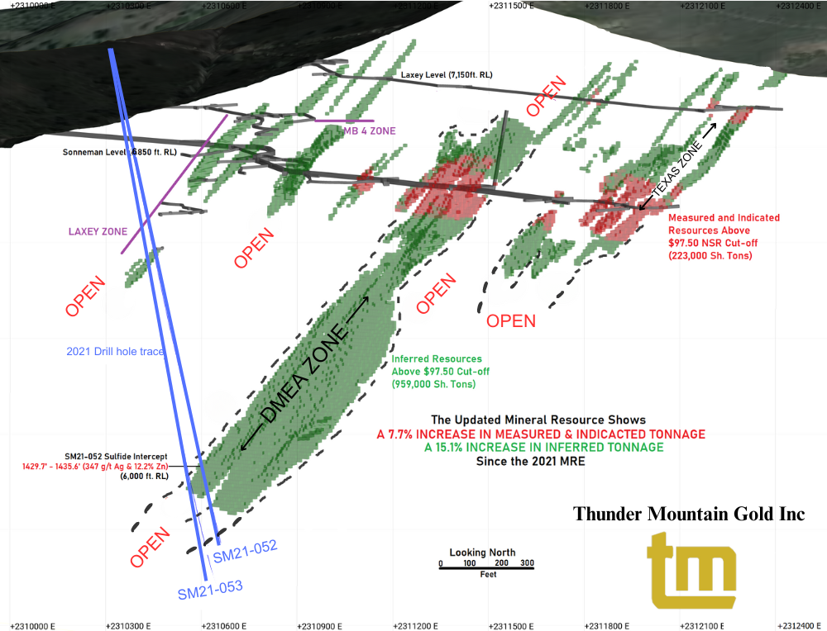

Qualified Person Statement for the Mineral Resource Estimate
Mr. Richard A. Schwering, P.G., SME-RM, a Resource Geologist with Hard Rock Consulting, LLC, is responsible for the South Mountain Project Mineral Resource Estimate with an effective date of October 16, 2023. Mr. Schwering is a Qualified Person as defined by NI43-101 and is independent of Thunder Mountain Gold Inc., and South Mountain Mines, Inc. Mr. Schwering estimated the mineral resources based on drill hole and channel sample data constrained by geologic boundaries using an Ordinary Krige algorithm. The Geologic Model and Mineral Resource Estimate were completed using Leapfrog Geo® Software version 2023.1.1. Hard Rock Consulting also completed the previous resource estimate.

QUALITY ASSURANCE AND QUALITY CONTROL PROCEDURES
The project employs a rigorous QC/QA program that includes blanks, duplicates, and appropriate certified standard reference material. All samples are introduced into the sample stream prior to sample handling/crushing to monitor analytical accuracy and precision. The insertion rate for the combined QA/QC samples is 10 percent or more depending upon batch sizes. ALS Global completed the analytical work with the core samples processed at their preparation facility in Reno, Nevada, U.S.A. All analytical and assay procedures are conducted in the ALS facility in North Vancouver, BC. The samples are processed by the following methods as appropriate to determine the grades; Au-AA23-Au 30g fire assay with AA finish, ME-ICP61-33 element four acid digest with ICP-AES finish, ME-OG62-ore grade elements, four acid with ICP-AES finish, Pb-OG62-ore grade Pb, four acid with ICP-AES finish, Zn-OG62-ore grade Zn, four acid digestion with ICP-AES finish, Ag-GRA21-Ag 30g fire assay with gravimetric finish.
The technical information in this news release has been reviewed and approved by Richard A. Schwering, SME-RM, P.G., Principal Resource Geologist, Hard Rock Consulting, LLC a “Qualified Person” as defined by National Instrument 43-101 standards.

The South Mountain Project

The South Mountain Mine is a polymetallic development project containing high-grade zinc, silver, gold, and copper, and is located approximately 70 miles southwest of Boise, Idaho (See Figure 2). The Project was intermittently mined from the late 1800s to the late 1960s and its existing underground workings remain intact and well maintained. Thunder Mountain Gold Inc. purchased and advanced the project from 2007 through 2022, with expenditures into the project of approximately US$20 million. Historic production at the Project has largely come from high-grade massive sulfide bodies that remain open at depth and along strike. According to historical smelter records, approximately 53,642 tons of mineralized material has been mined to date. These records also indicate average grades; 14.5% Zn, 10.6 o.p.t. Ag (363.42 g/t Ag), 0.058 o.p.t. Au (1.98 g/t Au), 1.4% Cu, and 2.4% Pb were realized (See NI 43-101 Technical Report: Updated Mineral Resource Estimate for the South Mountain Project, dated December 15, 2023, Section 6.4 – Table 6-3 for more details. Available on the Thunder Mountain Gold Inc. website and at www.sedar.com).

Figure 2. Location of South Mountain Project

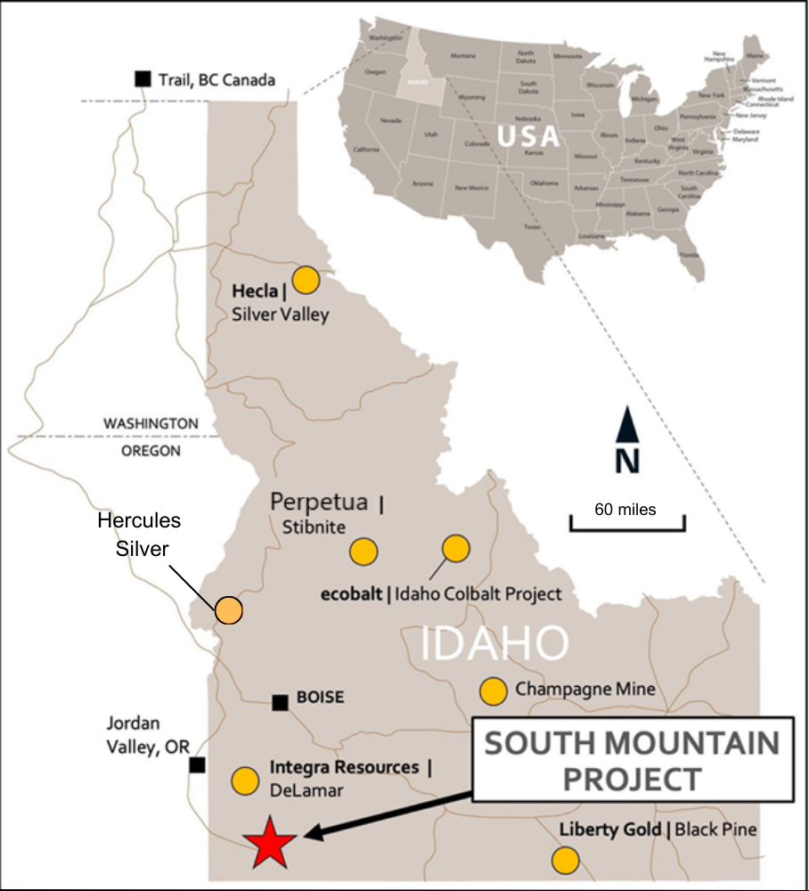

Regarding Thunder Mountain Gold, Inc.
Thunder Mountain Gold Inc., a junior exploration company founded in 1935, owns interests in base and precious metals projects in the western U.S. The Company’s principal asset is The South Mountain Mine, a historic former producer of zinc, silver, gold, lead, and copper, located on private land in Owyhee County Idaho. Thunder Mountain Gold also owns 100% of the Trout Creek Project – a gold exploration project located along the western flank of the Shoshone Mountain Range in the Reese River Valley, adjacent to and surrounded by Nevada Gold Mines, a joint operating agreement between Barrick and Newmont Gold, Inc. private mineral lands. For more information on Thunder Mountain Gold, please visit the Company’s website at www.Thundermountaingold.com.

Forward-Looking Statements
This press release contains forward-looking statements that are based on the beliefs of management and reflect the Company's current expectations. Generally, forward-looking statements can be identified by the use of forward-looking terminology such as “plans”, “expects”, “is expected”, “budget”, “scheduled”, “estimates”, “forecasts”, “intends”, “anticipates”, “believes” or variations of such words and phrases or statements that certain actions, events or results “may”, “could”, “would”, “might” or “will be taken”, “occur” or “be achieved” or the negative connotation thereof. The forward-looking statements are based on certain assumptions which could change materially in the future. By their nature, forward-looking information involves known and unknown risks, uncertainties and other factors that may cause actual results, performance or achievements to be materially different from any future results, performance or achievements expressed or implied by the forward-looking information. Investors should refer to THMG’s Form 10-K, Form 10-Q reports, for a more detailed discussion of risks that may impact future results. There can be no assurance that forward-looking information will prove to be accurate, as actual results and future events could differ materially from those anticipated in such statements. Accordingly, investors should not place undue reliance on forward-looking information. Forward-looking information is provided as of the date of this press release, and the Company assumes no obligation to update or revise them to reflect new events or circumstances, except as required in accordance with applicable laws.

Cautionary Note to Investors
Neither the TSX Venture Exchange nor its Regulation Services Provider (as that term is defined in policies of the TSX Venture Exchange) accepts responsibility for the adequacy or accuracy of this release.

For further information, please contact:

Thunder Mountain Gold, Inc.
Eric T. Jones
President and Chief Executive Officer
Eric@thundermountaingold.com
Office: (208) 658-1037

